WEBSITE TUTORIAL

## *~ Navigation Bar*

* Available on every page.
* Contains navigation to every page
* *Click* on each label to reach the corresponding page, *hover* to see which label

you’re currently on.

* *Click* on SpaceTD’s logo to reach home page.

## *~ Footer*

* Available on every page.
* Contains supposed links to SpaceTD’s social media and privacy policy.
* *Hover* to see which label you’re currently on.

## *~ Home Page*

* Banner : contains SpaceTD’s slogan and a brief description of what SpaceTD does.

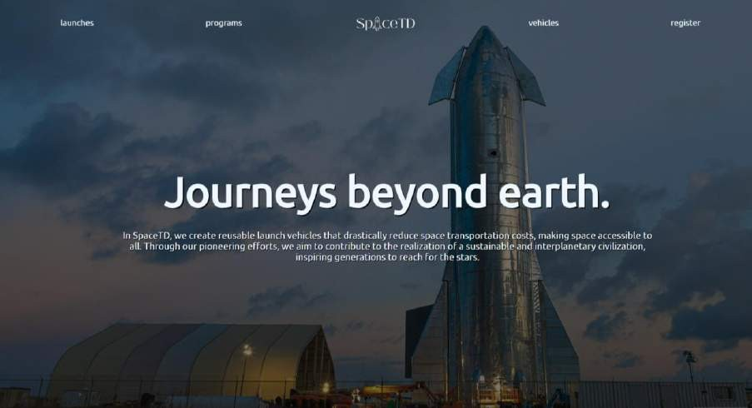

* Vision and SpaceTD’s numbers: *scroll down* from the banner to see SpaceTD’s

vision, total launches, total landings and total reflights

* Latest Rocket Launch Video: *scroll down* from numbers to see embedded video of the most recent rocket launch SpaceTD had done. *Click* on the video to play.

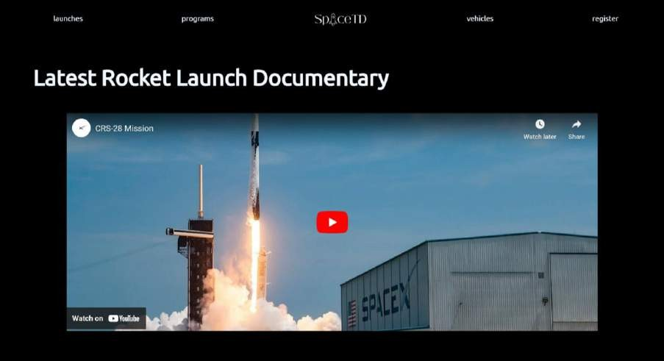

## *~ Launches Page*

* 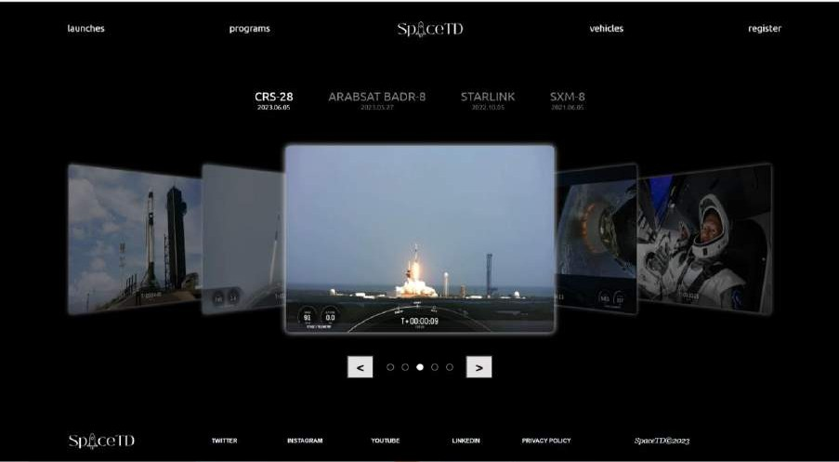Contains pictures of SpaceTD’s recent launches.
* Label: shows name of the mission and date of every mission, it will light up if it’s currently showing pictures of the corresponding mission. *Click* on the different labels to see the corresponding set of pictures.

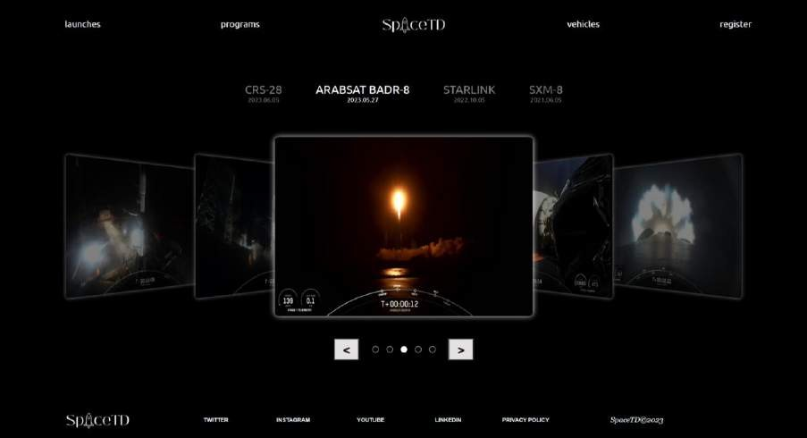

* Previous Button, Next Button, and Circles: circles that are filled show the order of pictures in the set. *Click* on the previous button to go to the previous picture and *click* on the next button to go to the next picture.

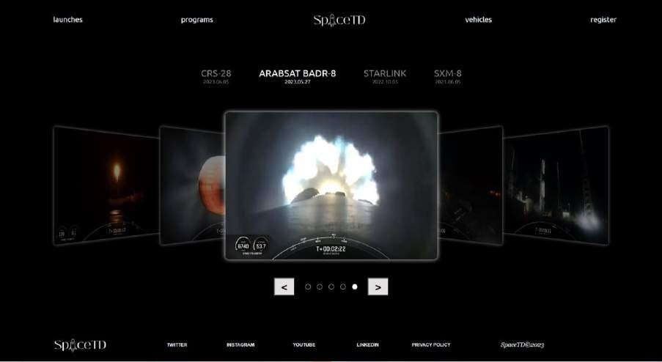

## *~ Programs Page*

* Contains information about SpaceTD’s space travel programs.
* Cards: shows the program’s description image, duration and route. *Click* on the cards to see a more detailed description of the corresponding program.

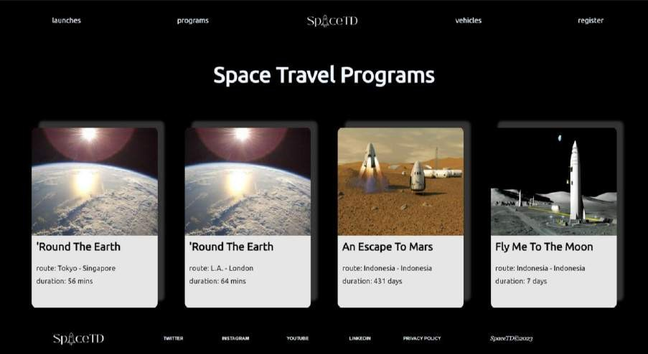

* Overlay: shows a more detailed description of the program. *Click* anywhere in the overlay to go back to the previous interface.

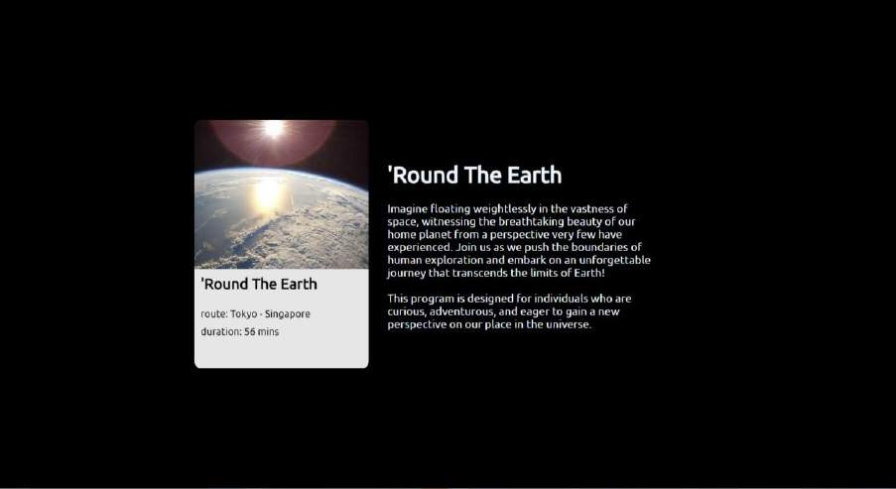

## *~ Vehicles Page*

* Contains information about SpaceTD’s space vehicles
* 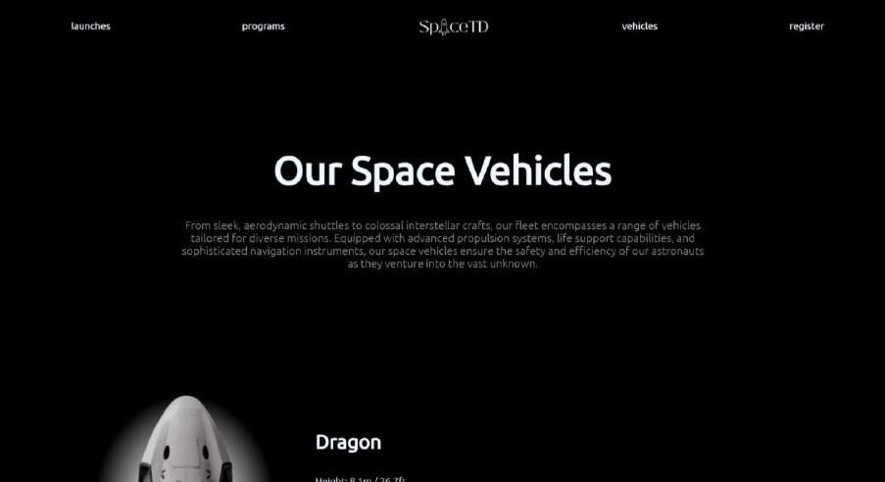Title and description
* Vehicles and Information: contains each vehicles’ names and height, diameter,

mass, also best-suited program. *Scroll down* to see the different vehicles.

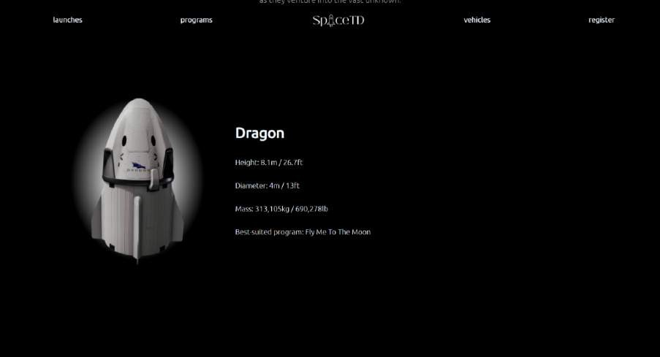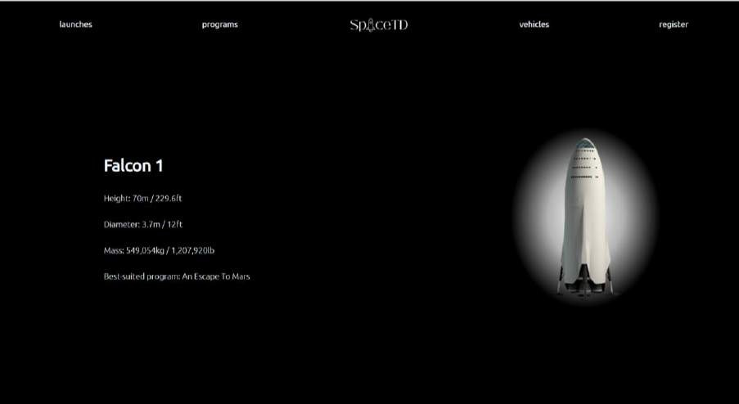

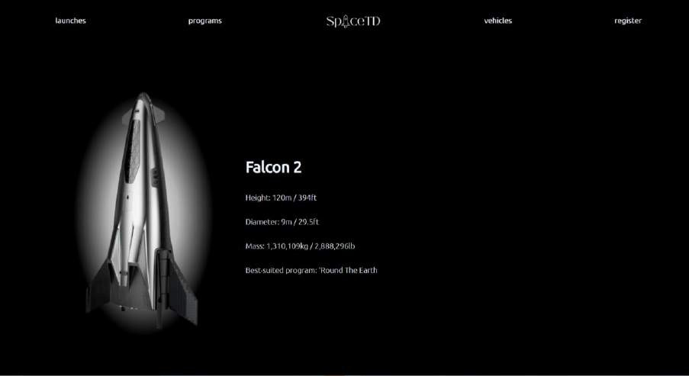

## *~ Register Page*

* Contains SpaceTD’S register form for its space travel program.
* Input fields:
  + Name, Email, Password: text input
  + Gender: radio buttons
  + Date of Birth: calendar selection
  + Country: dropdown list
* Validations:
  + All fields cannot be empty.
  + Age must be older than 18.
  + Can’t select ‘Country’ in country field.
  + Email must end with “@gmail.com”.
  + Password must be longer than 8 characters.
* *Click* submit button to validate form.

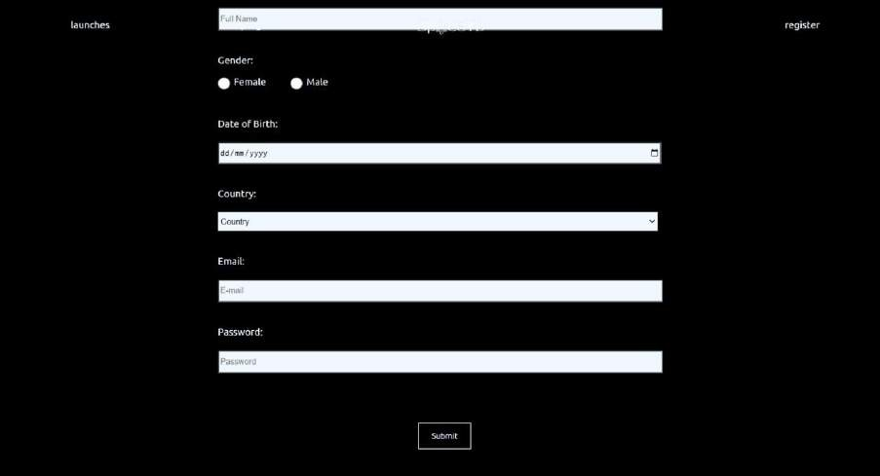

* Error message: if validations are not fulfilled, an error message will be displayed on the misinputted field.

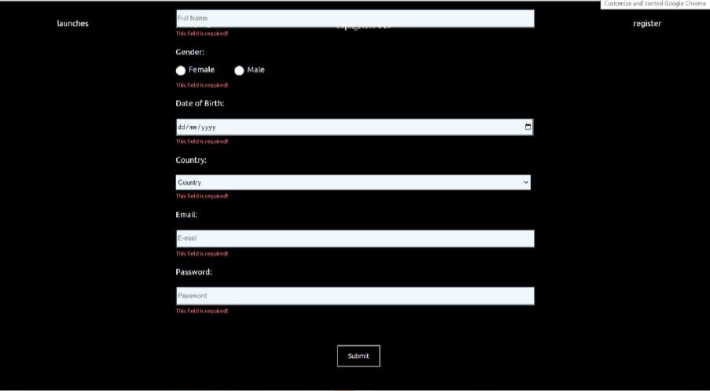

**Figma link to SpaceTD website:** [https://www.figma.com/file/TOdy0jzUYrH1RVK2fFVhBP/AoL-HCI-](https://www.figma.com/file/TOdy0jzUYrH1RVK2fFVhBP/AoL-HCI-Lab?type=design&node-id=0%3A1&t=YCMOuCV0cIKEAxcX-1) [Lab?type=design&node-id=0%3A1&t=YCMOuCV0cIKEAxcX-1](https://www.figma.com/file/TOdy0jzUYrH1RVK2fFVhBP/AoL-HCI-Lab?type=design&node-id=0%3A1&t=YCMOuCV0cIKEAxcX-1)

**Website inspirations:** <https://www.naughtyduk.com/> <https://www.teletech.events/moments> <https://www.spacex.com/>

**Image and Videos References:** SpaceX Official Website <https://www.spacex.com/>

SpaceX Official Youtube Channel [https://www.youtube.com/@SpaceX](https://www.youtube.com/%40SpaceX)

<https://i.ibb.co/341SyT0/Fgfe627-Vs-AAJ9n-Q.jpg>

[https://media.npr.org/assets/img/2023/04/17/52822624215_41cddfa832_4k-](https://media.npr.org/assets/img/2023/04/17/52822624215_41cddfa832_4k-16185313d6f4abc227ed55a2cbf5509de40a43a4-s1100-c50.jpg) [16185313d6f4abc227ed55a2cbf5509de40a43a4-s1100-c50.jpg](https://media.npr.org/assets/img/2023/04/17/52822624215_41cddfa832_4k-16185313d6f4abc227ed55a2cbf5509de40a43a4-s1100-c50.jpg)

https://cdn.vox- cdn.com/thumbor/T0lWaEDcsfJlqwuFI4e4fkJ9mjM=/0x0:2040x1360/2000x1333

/filters:focal(1322x753:1323x754)/cdn.vox- cdn.com/uploads/chorus_asset/file/19242766/pacalin_190928_3690_0005.0.jpg

[https://images.flyingmag.com/flyingma/wp-](https://images.flyingmag.com/flyingma/wp-content/uploads/2023/04/20120913/52822653368_36477f7324_k.jpg) [content/uploads/2023/04/20120913/52822653368_36477f7324_k.jpg](https://images.flyingmag.com/flyingma/wp-content/uploads/2023/04/20120913/52822653368_36477f7324_k.jpg)

[https://www.google.com/url?sa=i&url=https%3A%2F%2Fwww.technologyreview.co](https://www.google.com/url?sa=i&url=https%3A%2F%2Fwww.technologyreview.com%2F2021%2F12%2F07%2F1041420%2Fspacex-starship-rocket-solar-system-exploration%2F&psig=AOvVaw3UiU43Xfc8ZPHMxnAptb3R&ust=1686690730236000&source=images&cd=vfe&ved=0CBMQjhxqFwoTCKD0z-HSvv8CFQAAAAAdAAAAABAE) [m%2F2021%2F12%2F07%2F1041420%2Fspacex-starship-rocket-solar-system-](https://www.google.com/url?sa=i&url=https%3A%2F%2Fwww.technologyreview.com%2F2021%2F12%2F07%2F1041420%2Fspacex-starship-rocket-solar-system-exploration%2F&psig=AOvVaw3UiU43Xfc8ZPHMxnAptb3R&ust=1686690730236000&source=images&cd=vfe&ved=0CBMQjhxqFwoTCKD0z-HSvv8CFQAAAAAdAAAAABAE) [exploration%2F&psig=AOvVaw3UiU43Xfc8ZPHMxnAptb3R&ust=16866907302360](https://www.google.com/url?sa=i&url=https%3A%2F%2Fwww.technologyreview.com%2F2021%2F12%2F07%2F1041420%2Fspacex-starship-rocket-solar-system-exploration%2F&psig=AOvVaw3UiU43Xfc8ZPHMxnAptb3R&ust=1686690730236000&source=images&cd=vfe&ved=0CBMQjhxqFwoTCKD0z-HSvv8CFQAAAAAdAAAAABAE) [00&source=images&cd=vfe&ved=0CBMQjhxqFwoTCKD0z-](https://www.google.com/url?sa=i&url=https%3A%2F%2Fwww.technologyreview.com%2F2021%2F12%2F07%2F1041420%2Fspacex-starship-rocket-solar-system-exploration%2F&psig=AOvVaw3UiU43Xfc8ZPHMxnAptb3R&ust=1686690730236000&source=images&cd=vfe&ved=0CBMQjhxqFwoTCKD0z-HSvv8CFQAAAAAdAAAAABAE) [HSvv8CFQAAAAAdAAAAABAE](https://www.google.com/url?sa=i&url=https%3A%2F%2Fwww.technologyreview.com%2F2021%2F12%2F07%2F1041420%2Fspacex-starship-rocket-solar-system-exploration%2F&psig=AOvVaw3UiU43Xfc8ZPHMxnAptb3R&ust=1686690730236000&source=images&cd=vfe&ved=0CBMQjhxqFwoTCKD0z-HSvv8CFQAAAAAdAAAAABAE)

[https://1.bp.blogspot.com/-](https://1.bp.blogspot.com/-HrHRWXZwKAc/X0WNqO71enI/AAAAAAAAFJA/hltPLE2MZGYv2Q8qU3uWZCnCYCY2wNu7ACLcBGAsYHQ/s1000/SpaceX%2Borbital%2Bshuttle%2Bconcept%2Bby%2BRodrigo%2BMagro.jpg) [HrHRWXZwKAc/X0WNqO71enI/AAAAAAAAFJA/hltPLE2MZGYv2Q8qU3uWZCn](https://1.bp.blogspot.com/-HrHRWXZwKAc/X0WNqO71enI/AAAAAAAAFJA/hltPLE2MZGYv2Q8qU3uWZCnCYCY2wNu7ACLcBGAsYHQ/s1000/SpaceX%2Borbital%2Bshuttle%2Bconcept%2Bby%2BRodrigo%2BMagro.jpg)

[CYCY2wNu7ACLcBGAsYHQ/s1000/SpaceX%2Borbital%2Bshuttle%2Bconcept%2B](https://1.bp.blogspot.com/-HrHRWXZwKAc/X0WNqO71enI/AAAAAAAAFJA/hltPLE2MZGYv2Q8qU3uWZCnCYCY2wNu7ACLcBGAsYHQ/s1000/SpaceX%2Borbital%2Bshuttle%2Bconcept%2Bby%2BRodrigo%2BMagro.jpg) [by%2BRodrigo%2BMagro.jpg](https://1.bp.blogspot.com/-HrHRWXZwKAc/X0WNqO71enI/AAAAAAAAFJA/hltPLE2MZGYv2Q8qU3uWZCnCYCY2wNu7ACLcBGAsYHQ/s1000/SpaceX%2Borbital%2Bshuttle%2Bconcept%2Bby%2BRodrigo%2BMagro.jpg)

[https://www.renderhub.com/renatodalle/spacex-big-falcon-9/spacex-big-falcon-9-](https://www.renderhub.com/renatodalle/spacex-big-falcon-9/spacex-big-falcon-9-01.jpg) [01.jpg](https://www.renderhub.com/renatodalle/spacex-big-falcon-9/spacex-big-falcon-9-01.jpg)

[https://media.sketchfab.com/models/b4189c6d1dad404a8ea25cad042161c1/thumb](https://media.sketchfab.com/models/b4189c6d1dad404a8ea25cad042161c1/thumbnails/eda322c955d74c53a6b63a1ca5f1043f/fbaddacf29c94f6e91d42036f15e7c4f.jpeg) [nails/eda322c955d74c53a6b63a1ca5f1043f/fbaddacf29c94f6e91d42036f15e7c4f.jpeg](https://media.sketchfab.com/models/b4189c6d1dad404a8ea25cad042161c1/thumbnails/eda322c955d74c53a6b63a1ca5f1043f/fbaddacf29c94f6e91d42036f15e7c4f.jpeg)

<https://cdn.mos.cms.futurecdn.net/mz5caQYpp2cbHm64pCnRBZ.jpg>

[https://imgix.bustle.com/inverse/40/f8/12/e9/2774/48cd/a3e6/82cf3f6f4c86/artis](https://imgix.bustle.com/inverse/40/f8/12/e9/2774/48cd/a3e6/82cf3f6f4c86/artists-rendition-of-the-spacex-dragon-capsule-on-mars.jpeg?w=1200&h=630&fit=crop&crop=faces&fm=jpg) [ts-rendition-of-the-spacex-dragon-capsule-on-](https://imgix.bustle.com/inverse/40/f8/12/e9/2774/48cd/a3e6/82cf3f6f4c86/artists-rendition-of-the-spacex-dragon-capsule-on-mars.jpeg?w=1200&h=630&fit=crop&crop=faces&fm=jpg) [mars.jpeg?w=1200&h=630&fit=crop&crop=faces&fm=jpg](https://imgix.bustle.com/inverse/40/f8/12/e9/2774/48cd/a3e6/82cf3f6f4c86/artists-rendition-of-the-spacex-dragon-capsule-on-mars.jpeg?w=1200&h=630&fit=crop&crop=faces&fm=jpg)

[https://kubrick.htvapps.com/htv-prod-media.s3.amazonaws.com/images/spacex-](https://kubrick.htvapps.com/htv-prod-media.s3.amazonaws.com/images/spacex-1492919258.jpg?crop=1xw%3A1xh%3Bcenter%2Ctop) [1492919258.jpg?crop=1xw:1xh;center,top](https://kubrick.htvapps.com/htv-prod-media.s3.amazonaws.com/images/spacex-1492919258.jpg?crop=1xw%3A1xh%3Bcenter%2Ctop)

# Font : Ubuntu

@import url('https://fonts.googleapis.com/css?family=Ubuntu'); @import

url('https://fonts.googleapis.com/css2?family=Ubuntu:wght@300&display=s wap');

[https://fonts.googleapis.com/css?family=Ubuntu](https://fonts.google.com/css?family=Ubuntu) [https://fonts.googleapis.com/css2?family=Ubuntu:wght@300&display=swap](https://fonts.googleapis.com/css2?familt=Ubuntu%3Awght%40300&display=swap)

# HTML, CSS & JS references:

Documentation <https://www.w3schools.com/html/default.asp>

Slider https://www.youtube.com/watch?v=OQZNAMjC6Vghttps[://w](http://www.youtube.com/wat)ww[.you](http://www.youtube.com/wat)t[ube.com/wat](http://www.youtube.com/wat) ch?v=OQZNAMjC6Vg

Scroll animation <https://www.youtube.com/watch?v=peFOHcbEUig>

3D in CSS

<https://www.youtube.com/watch?v=MmdKeypSxE8>

3D image slider [https://drive.google.com/file/d/1hENANTV4cHgQcKOXCmWwQW5aLlufZsoF/vie](https://drive.google.com/file/d/1hENANTV4cHgQcKOXCmWwQW5aLlufZsoF/view) [w](https://drive.google.com/file/d/1hENANTV4cHgQcKOXCmWwQW5aLlufZsoF/view)

JavaScript age validation <https://www.javatpoint.com/calculate-age-using-javascript>

Responsive navbar <https://www.youtube.com/watch?v=At4B7A4GOPg>